Samarth Rural Educational Institute’s
Samarth College of Computer Science, Belhe
Academic Year 2026-2027(SEM-V)
T.Y.B.Sc.(Information Technology)
Practical NO:1
Title : 1. Basic HTML Page Design
Roll NO: 70 Batch : C

SET A:
Q1. Create an HTML page displaying your personal profile (Name, Class, Email).
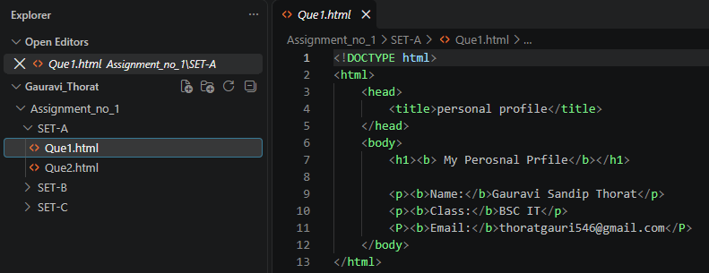

Output:
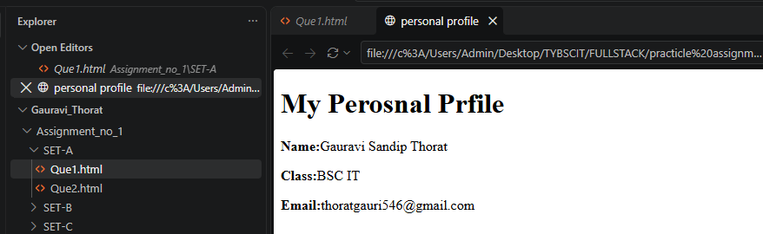

Q2. Create an HTML page showing your weekly timetable using a table.
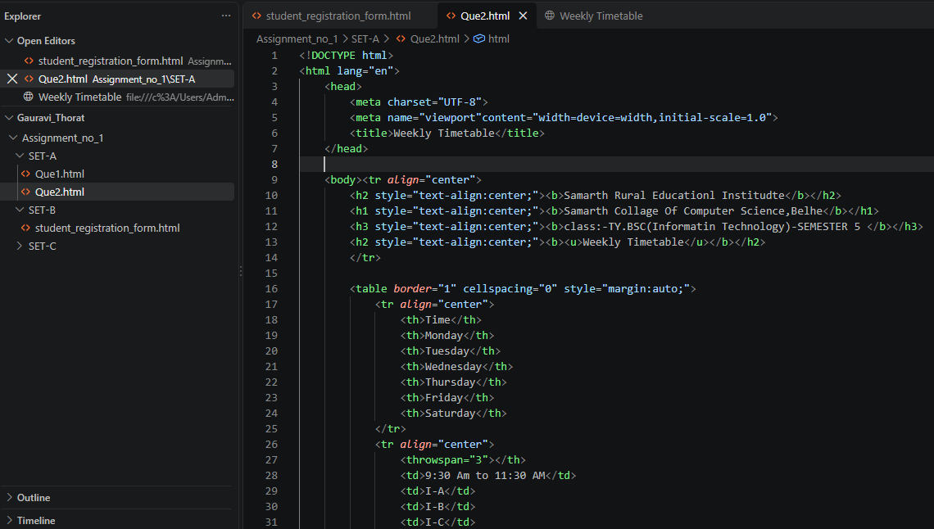
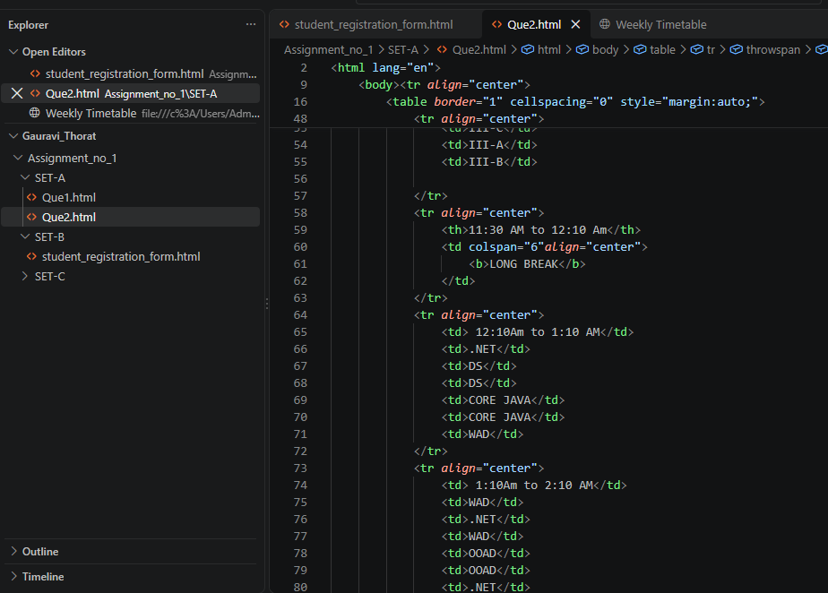
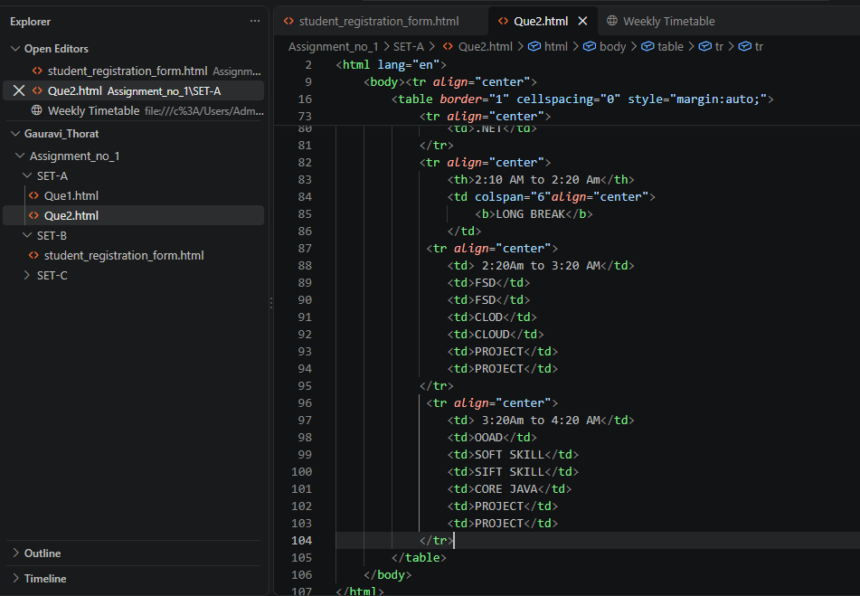

Output: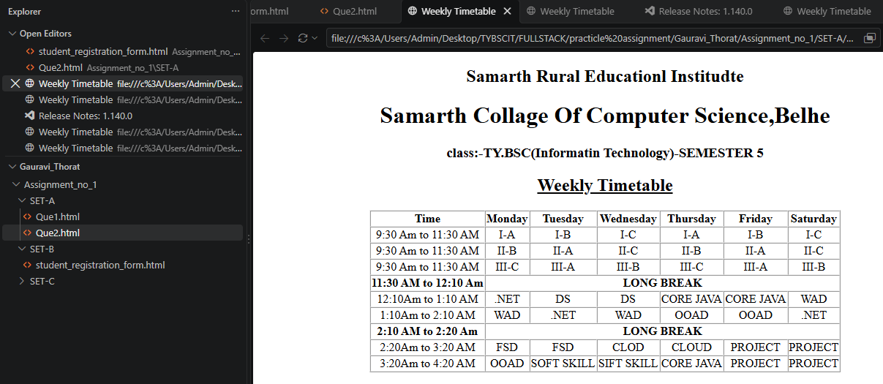

SET B:
Q3. Create an HTML page containing a student registration form.
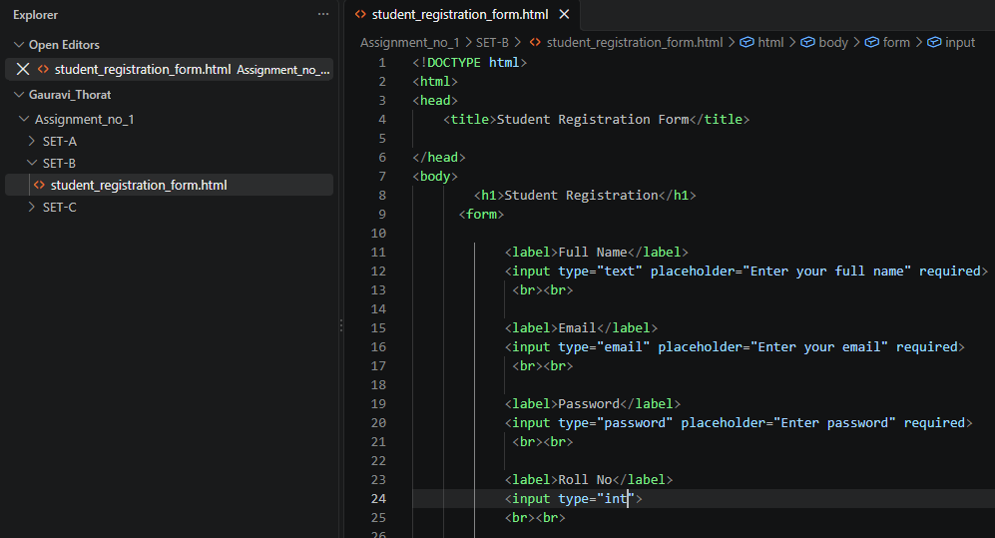
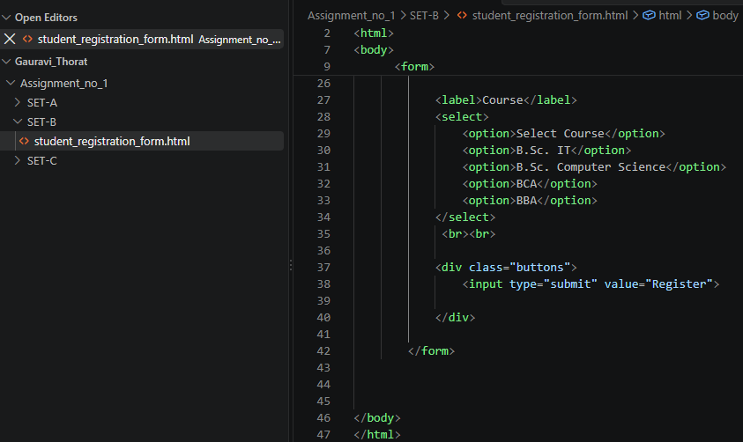

Output:
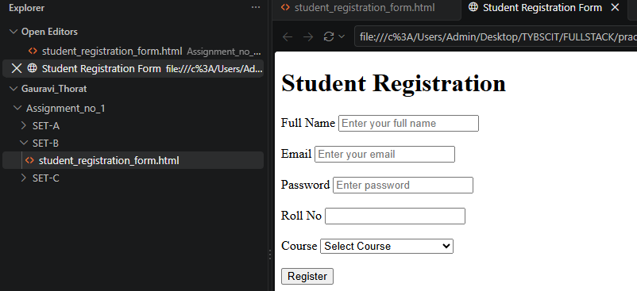
SET C:
Q4. Design a college website homepage using headings, images, links, and lists.
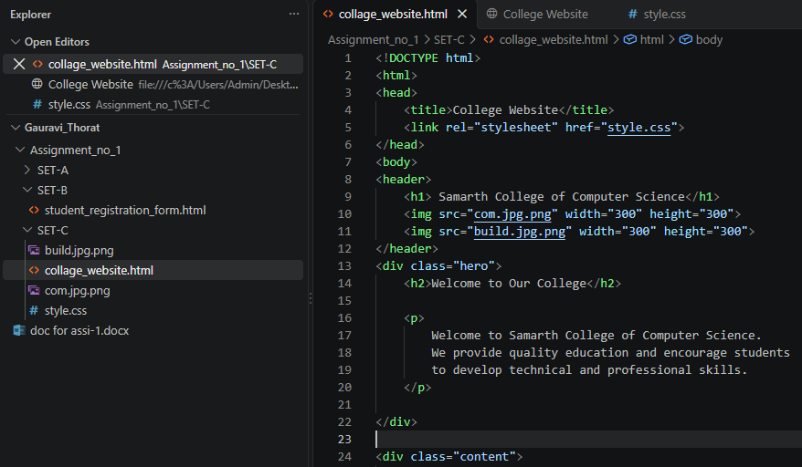
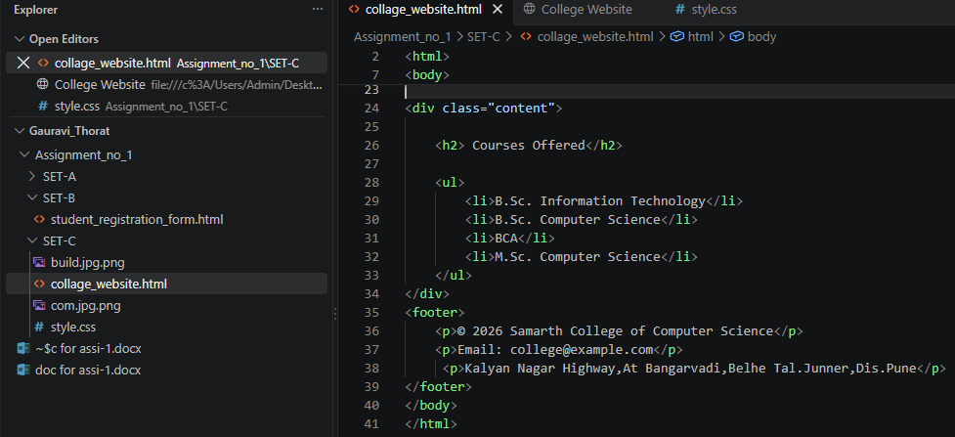
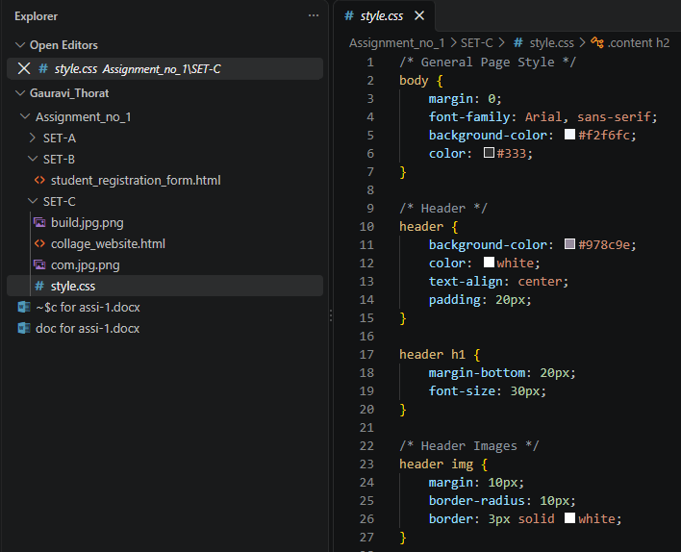

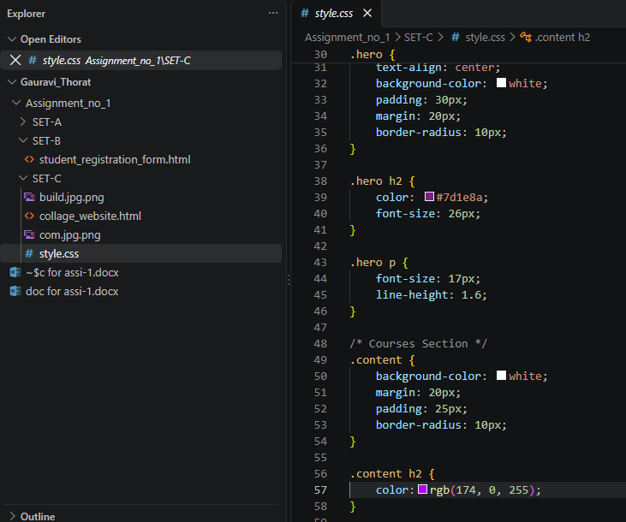

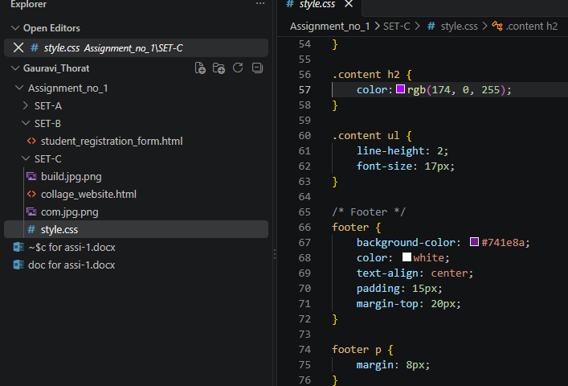
Output:
